**Greenhouse Gas Cost of Beef Restaurant Menu Options**

**INTRODUCTION/BUSINESS PROBLEM**

Anyone who is committed to preserving the planet and/or protecting the health of themselves and their loved ones should be motivated to expand their understanding of the complex network of causes driving the global climate crisis we face. Only recently did I become aware of the environmental impact of my food choices. On its website, the EPA (Environmental Protection Agency) defines GWP (Global Warming Potential) as a measure of gases other than CO2 and how they warm the Earth. The information below provides some facts about the GWP of methane (a gas generated by beef/pork production):

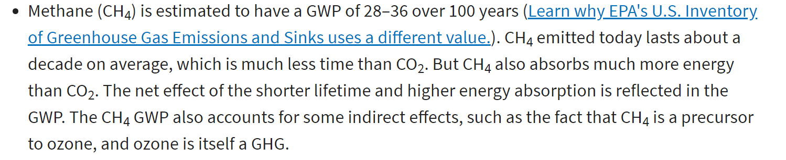

link: <https://www.epa.gov/ghgemissions/understanding-global-warming-potentials>

In this analysis, I will attempt to quantify the Greenhouse Gas Emissions cost of purchasing beef or pork products from a retail food establishment. This should be of importance to a variety of stakeholders, including consumers, regulatory authorities, legislative officials, and businesses that are motivated to improve sustainability practices and reduce their contribution to our global warming crisis. In addition to a review of the statistics relating to beef/pork consumption, my analysis will incorporate Foursquare location data to examine a location’s Greenhouse Gas Emissions Cost associated with beef consumption. Ideally, this would be material information considered as part of the approval process associated with opening new businesses. It should also have an impact on ordinances/regulations governing existing restaurants.

**Greenhouse Gas Cost of Beef Restaurant Menu Options**

**DATA**

The most popular sandwich at a leading fast food restaurant contains 211g (7.4 oz) of beef. Consumers of this sandwich may not know that they are also purchasing a Greenhouse Gas Emissions unit equal to driving a car almost 9.81 miles (7.40 pounds of CO2-equivalent emissions from producing half a pound of beef – link: [How Meat Contributes to Global Warming - Scientific American](https://www.scientificamerican.com/slideshow/the-greenhouse-hamburger/)). An informative publication by the NRDC tells us that beef “contributes more climate-warming pollution than any other food in the American diet.” (link: <https://www.nrdc.org/sites/default/files/less-beef-less-carbon-ip.pdf>

Restaurant menu data sources will include Foursquare and other published datasets (including [Nutrition Facts for McDonald's Menu | Kaggle](https://www.kaggle.com/mcdonalds/nutrition-facts) ). After gathering this data, I plan to utilize the EPA’s Greenhouse Gas Equivalencies Calculator (link: <https://www.epa.gov/energy/greenhouse-gas-equivalencies-calculator>) to measure the Greenhouse Gas Cost of each menu. From this, I will be able to use Foursquare location data to provide a visual representation of the Greenhouse Gas Costs of a location’s retail food establishments.